**Workshop on Financial Education**

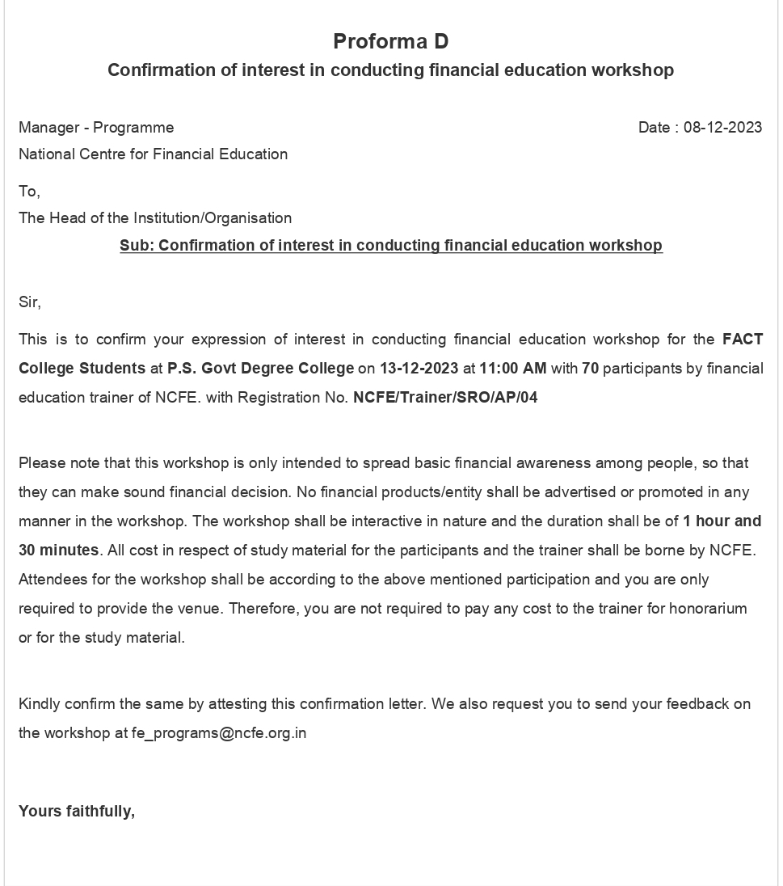

**PS Govt. Degree College, Penukonda-515110**

Workshop on Financial Education



* On 08-12-2023 conducted workshop on financial education with the association of Sri. Rajendra Prasad (Trainer), National Centre for Financial Education, under the chairmanship of college principal Dr. J.V.V.N Kesava Rao. 57 students were participated and got awareness on various aspects like tracking personal income, saving methods, stock market concepts and schemes, handling financial situations. This is the best programme though which our students got more knowledge about various financial issues.

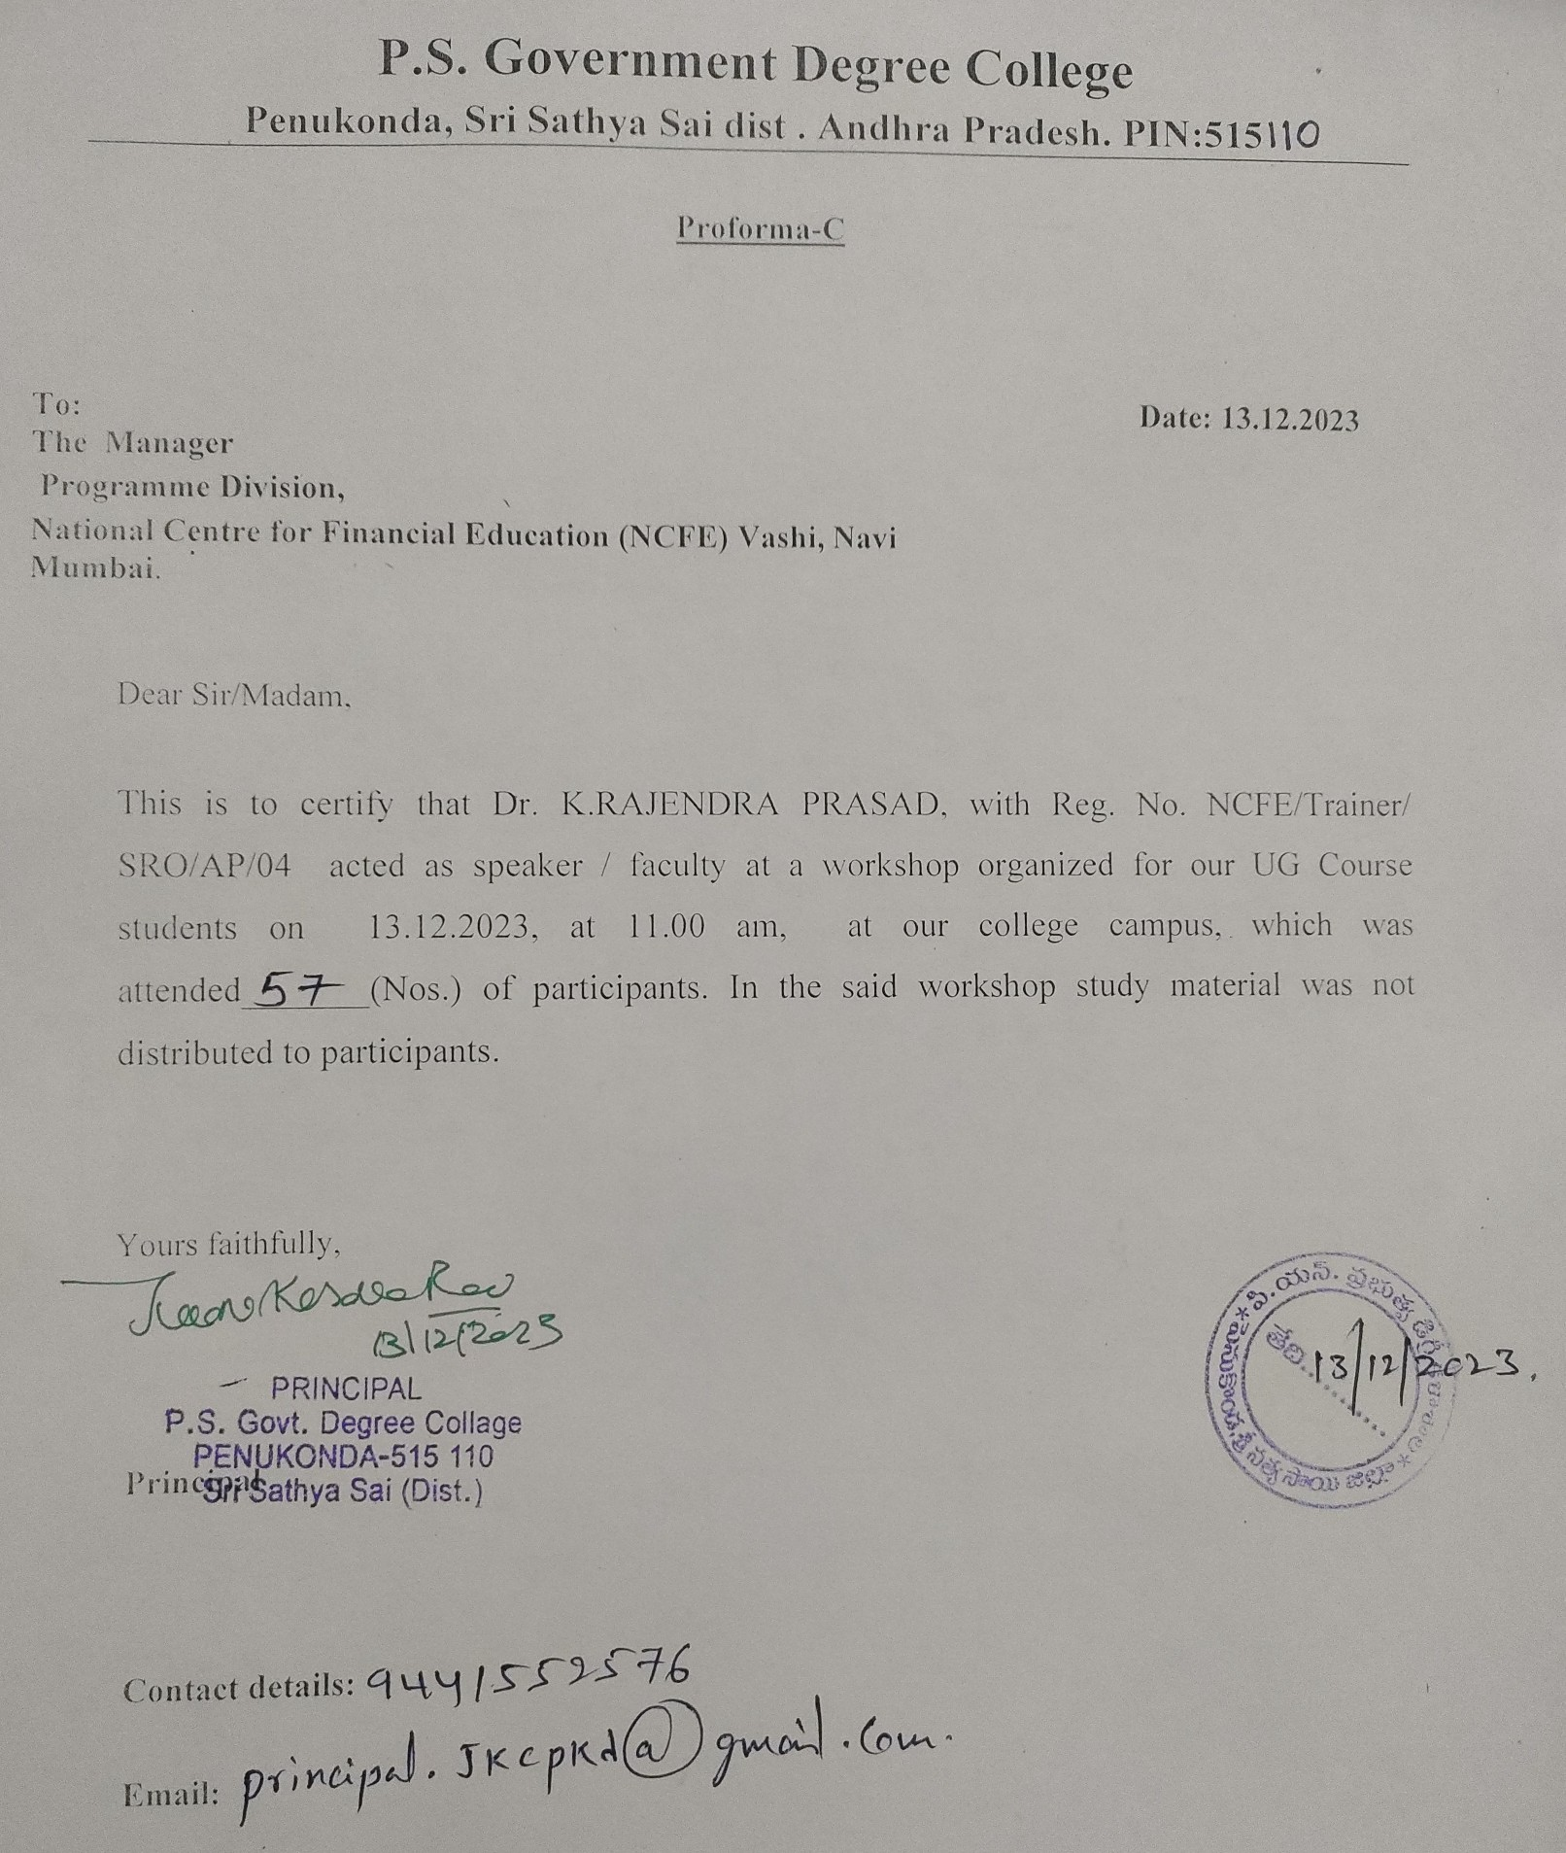

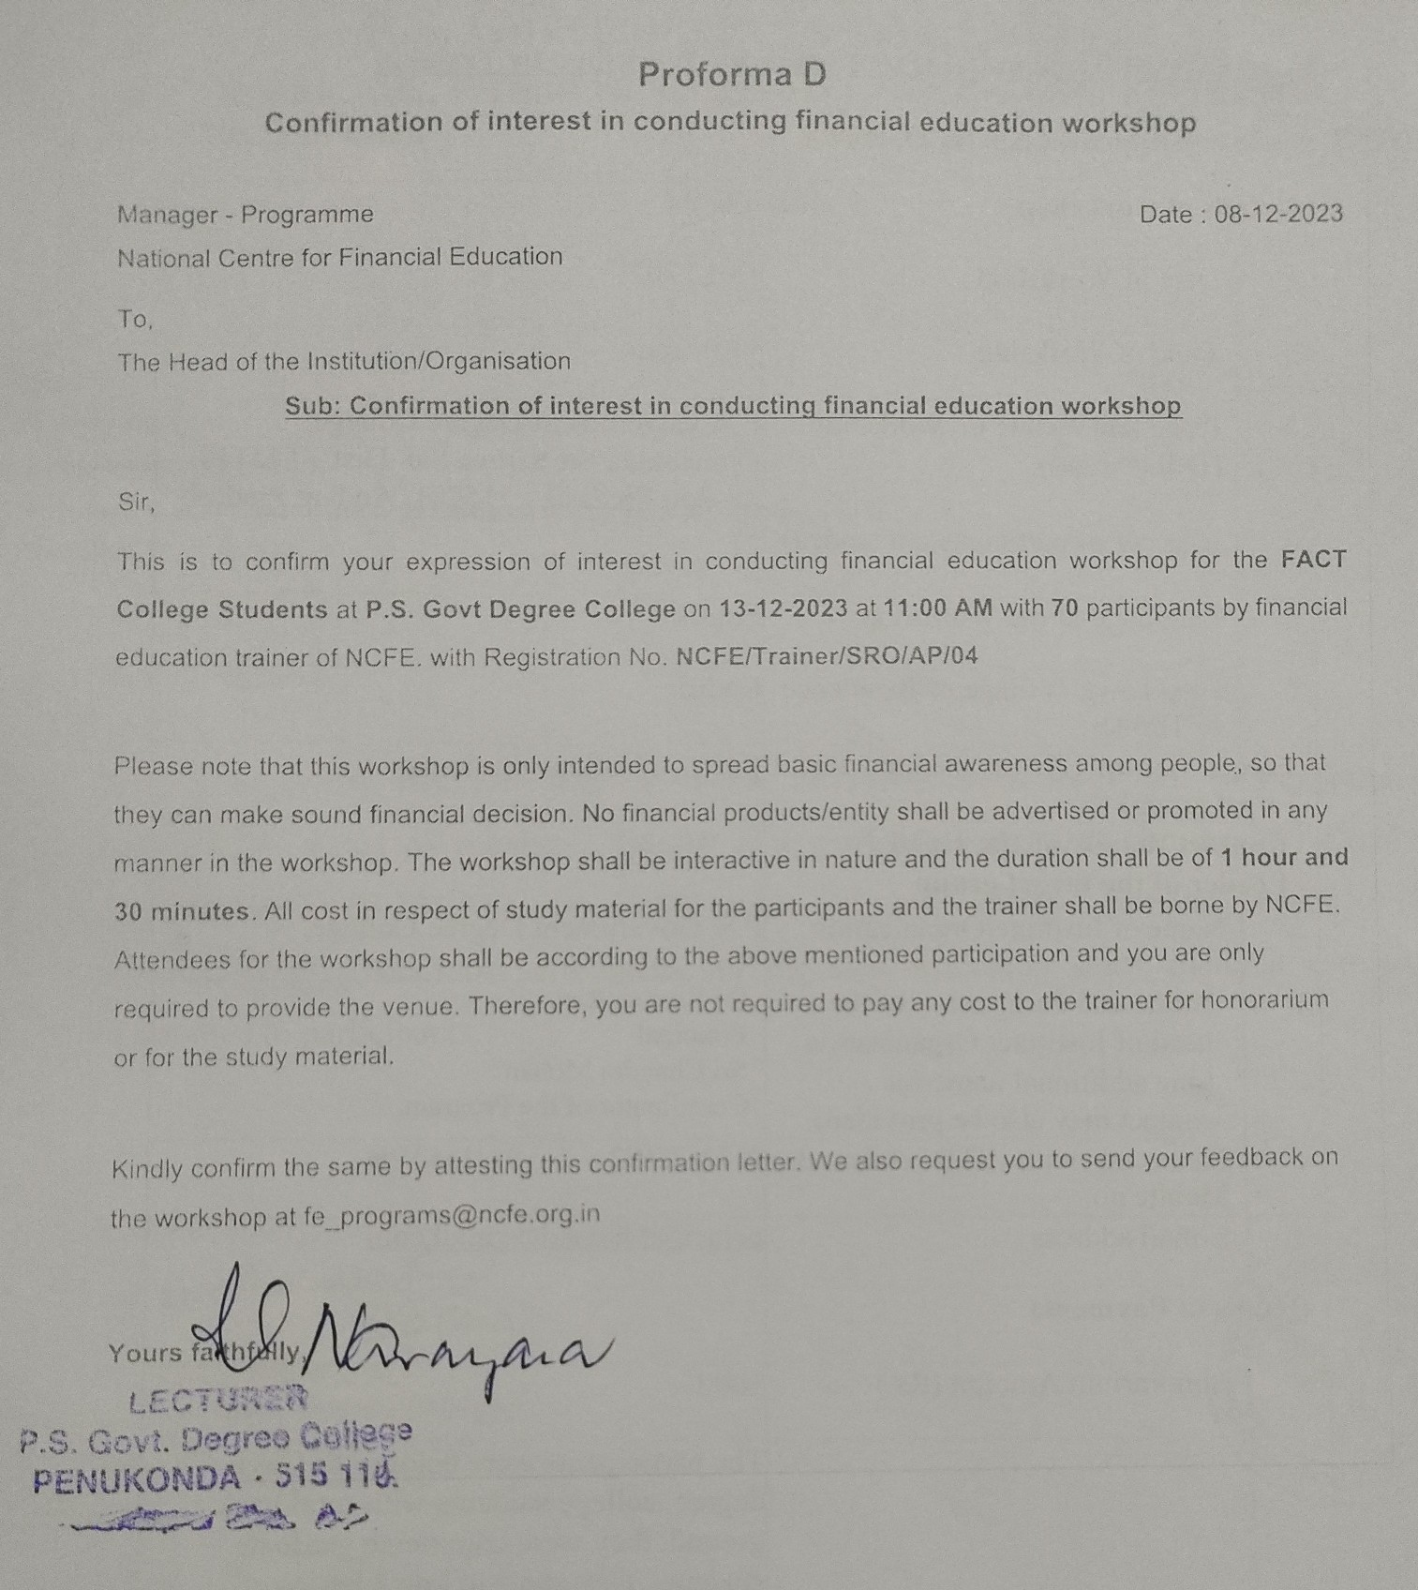

2

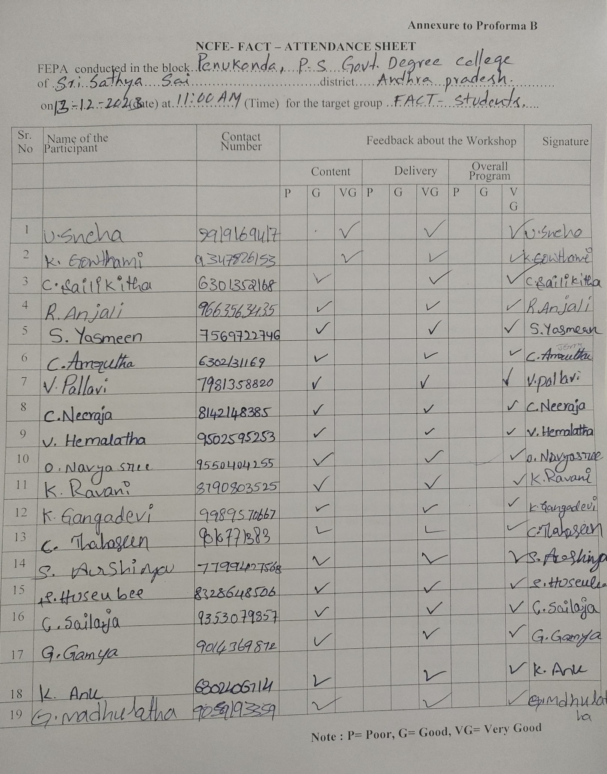

3

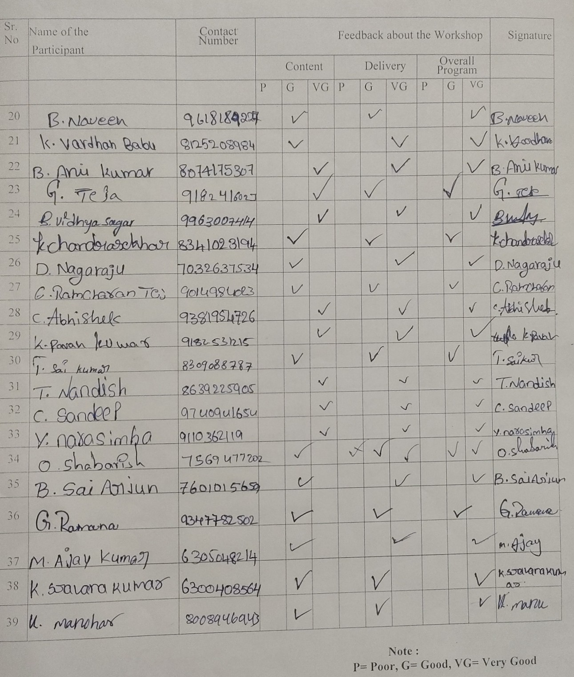

4

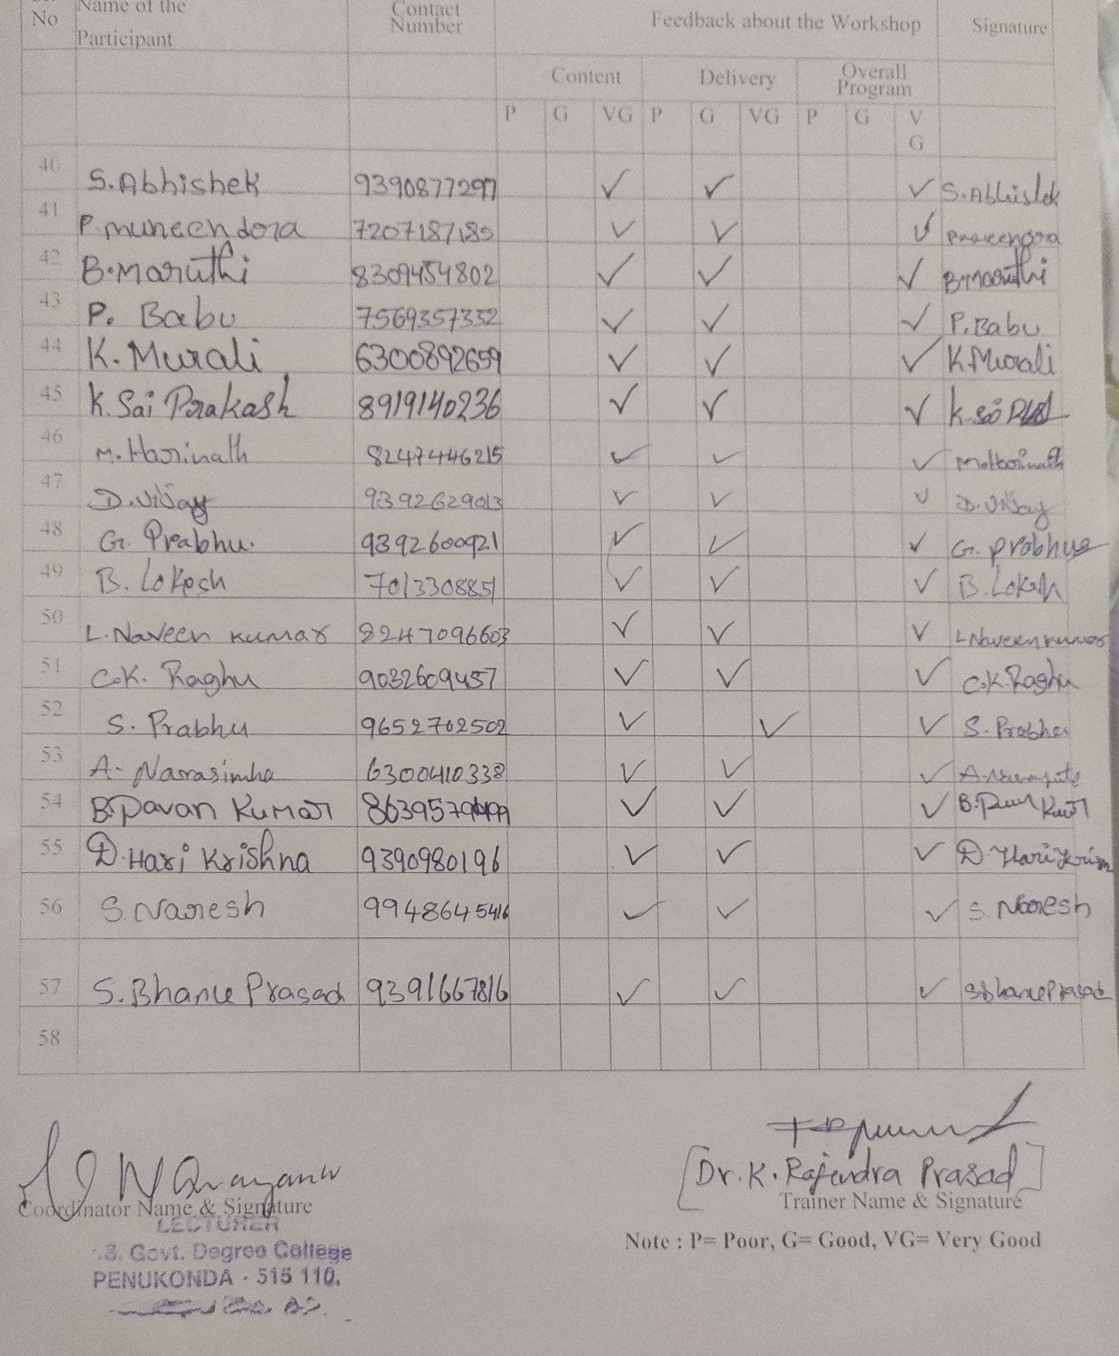

5

**Outcomes of Financial Education Workshop**

1. Our students got awareness on tracking personal Spending.
2. Students learned the methods to save money from their Income.
3. Got awareness on effective utilization of financial resources.
4. Learned the various saving plans and schemes provided by the Central and State Government.
5. Our students got awareness on the basic concepts of Stock Market
6. At the end of the session students are able to analyze and evaluate their financial situation.